Лабораторна робота №2
Тема: Використання методів розширень та узагальнень у C#.
Мета роботи: навчитися використовувати методи розширення та узагальнення у мові програмування C#.

Хід роботи:
Завдання 1:

Лістинг:

using System;
using System.Text;
using System.Collections.Generic;
namespace ConsoleApp1
{
class Proфgram
{
static void Main(string[] args)
{
string s = "Hello world";
Console.WriteLine("Count of 'l':");
Console.WriteLine($"{s.WordCount('l')}");
Console.WriteLine("Reverse:");
Console.WriteLine($"{s.StringReverse()}\n");
int[] arr = new int[] { 1, 2, 3, 4, 5, 3, 2, 1 };
Console.WriteLine(" [1,2,3,4,5,3,2,1]");
Console.WriteLine($"Arr int Count of '1':{arr.CountElem<int>(1)}");
double[] arr3 = new double[] { 1, 2, 3, 4, 5, 3, 2, 1 };
Console.WriteLine($"Arr double Count of '3': {arr3.CountElem<double>(3)} ");
string[] arr2 = new string[] { "Bloha", "Krevetka", "Jaba", "Jaba", "Pinguin" };
string str = "Krevetka";
Console.WriteLine($"Arr string Count of 'Krevetka': {arr2.CountElem<string>(str)} ");
char[] arr4 = new char[] { 'o', 'a', 'o', 'a', 'q', 'w', 'e', 'r' };
char str1 = 'q';
Console.WriteLine($"Arr char Count of 'q': {arr4.CountElem<char>(str1)} ");
Console.Write($"DOUBLE ARRAY\n ");
double[] arr6 = new double[] { 1, 2, 3, 4, 5, 3, 2, 1 };
double[] arr7 = arr6.ArrUnique<double>();
foreach (double i in arr7)
{
Console.Write($"{i} ");
}
Console.Write($"\n");
Console.Write($"STRING ARRAY\n");
string[] arr8 = new string[] { "Bloha", "Krevetka", "Jaba", "Jaba", "Pinguin" };

string[] arr9 = arr8.ArrUnique<string>();
foreach (string i in arr9)
{
Console.Write($"{i} ");
}
}
}
public static class StringExtension
{
public static int WordCount(this string str, char c)
{
int counter = 0;
for (int i = 0; i < str.Length; i++)
{
if (str[i] == c)
counter++;
}
return counter;
}
public static string StringReverse(this string str)
{
StringBuilder s = new StringBuilder();
for (int i = str.Length - 1; i >= 0; i--)
{
s.Append(str[i]);
}
return s.ToString();
}
}
public static class ArrayExtension
{
public class RequireClass<TypeArr> where TypeArr : class { }
public static int CountElem<TypeArr>(this TypeArr[] arr, TypeArr elem)
where TypeArr : struct
{
int count = 0;
for (int i = 0; i < arr.Length; i++)
{
if (object.Equals(arr[i], elem))
{
count++;
}
}
return count;
}
public static int CountElem<TypeArr>(this TypeArr[] arr, TypeArr elem,
RequireClass<TypeArr> ignore = null) where TypeArr : class
{
int count = 0;
for (int i = 0; i < arr.Length; i++)
{
if (object.Equals(arr[i], elem))
{
count++;
}
}
return count;
}

public static TypeArr[] ArrUnique<TypeArr>(this TypeArr[] arr) where
TypeArr : struct
{
List<TypeArr> list = new List<TypeArr>();
for (int i = 0; i < arr.Length; i++)
{
if (list.IndexOf(arr[i]) == -1)
{
list.Add(arr[i]);
}
}
TypeArr[] ArrUnique = new TypeArr[list.Count];
for (int i = 0; i < ArrUnique.Length; i++)
{
ArrUnique[i] = list[i];
}
return ArrUnique;
}
public static TypeArr[] ArrUnique<TypeArr>(this TypeArr[] arr,
RequireClass<TypeArr> ignore = null) where TypeArr : class
{
List<TypeArr> list = new List<TypeArr>();
for (int i = 0; i < arr.Length; i++)
{
if (list.IndexOf(arr[i]) == -1)
{
list.Add(arr[i]);
}
}
TypeArr[] ArrUnique = new TypeArr[list.Count];
for (int i = 0; i < ArrUnique.Length; i++)
{
ArrUnique[i] = list[i];
}
return ArrUnique;
}
}
}

Результат виконання:

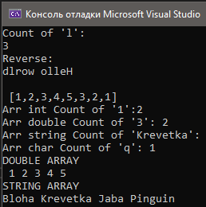

Завдання 2:

Лістинг ExtendedDictionary:

using System;
using System.Collections.Generic;
using System.Text;
using System.Threading.Tasks;
namespace ClassLibrary1
{
public class ExtendedDictionary<Key, Value1, Value2>
{
protected List<ExtendedDictionaryElement<Key, Value1, Value2>> dict = new
List<ExtendedDictionaryElement<Key, Value1, Value2>>();
public void Add(Key key, Value1 val1, Value2 val2)
{
foreach (ExtendedDictionaryElement<Key, Value1, Value2> i in dict)
{
if (object.Equals(i.key, key))
{
Console.WriteLine("Key exists");
return;
}
}
ExtendedDictionaryElement<Key, Value1, Value2> line = new
ExtendedDictionaryElement<Key, Value1, Value2>();
line.key = key;
line.value1 = val1;
line.value2 = val2;
dict.Add(line);
}
public void Print()
{
foreach (ExtendedDictionaryElement<Key, Value1, Value2> i in dict)
{
Console.WriteLine($"{i.key} - {i.value1} - {i.value2}");
}
}
public void Remove(Key elem)
{
for (int i = 0; i < dict.Count; i++)
{
if (object.Equals(dict[i].key, elem))
{
dict.RemoveAt(i);
return;
}
}
}
public void ExistKey(Key elem)
{
int iss = 0;
int ind = 0;
for (int i = 0; i < dict.Count; i++)
{
if (object.Equals(dict[i].key, elem))
{
iss++;
ind = i;
}
}
if (iss == 0)
Console.WriteLine("Key does not exist");
else
Console.WriteLine($"Key exist - index: {ind}");
}
public int Count()
{
return dict.Count;
}
public void ExistValues(Value1 val1, Value2 val2)
{
int ind = 0;
bool ter = false;
for (int i = 0; i < dict.Count; i++)
{
if ((object.Equals(dict[i].value1, val1)) &&
(object.Equals(dict[i].value2, val2)))
{
ind = i;
ter = true;
}
}
if (ter)
{
Console.WriteLine($"Val1 and Val2 is at Key[{ind}]");
}
else
Console.WriteLine($"Val1 and Val2 is not exist");
}
private int ind = 0;
public ExtendedDictionaryElement<Key, Value1, Value2> this[Key key]
{
get
{
for (int i = 0; i < dict.Count; i++)
{
if (object.Equals(dict[i].key, key))
{
ind = i;
}
}
return dict[ind];
}
}
public IEnumerator<ExtendedDictionaryElement<Key, Value1, Value2>>
GetEnumerator()
{
for (int i = 0; i < dict.Count; i++)
{
yield return dict[i];
}
}
}
}

Лістинг ExtendedDictionaryElement:

using System;
using System.Collections.Generic;
using System.Text;
using System.Threading.Tasks;
namespace ClassLibrary1
{
public class ExtendedDictionaryElement<Key, Value1, Value2>
{
public Key key { set; get; }
public Value1 value1 { set; get; }
public Value2 value2 { set; get; }
}
}

Лістинг:

using System;
using System.Collections.Generic;
using System.Text;
using System.Threading.Tasks;
using ClassLibrary1;
namespace ConsoleApp2
{
class Program
{
static void Main(string[] args)
{
Console.WriteLine("Hello World!");
ExtendedDictionary<int, string, string> dict = new
ExtendedDictionary<int, string, string>();
dict.Add(1, "Anton", "Lozovyi");
dict.Add(2, "Anton", "Ilya");
dict.Add(3, "Anton", "NovikKopat");
dict.Add(1, "Perfecto", "Ilya");
dict.Add(4, "Anton", "Muzhilunski");
dict.Add(5, "Ivan", "Kopat");
dict.Print();
Console.WriteLine("-------------------------");
dict.Remove(5);
dict.Print();
Console.WriteLine("-------------------------");
dict.ExistKey(4);
dict.ExistKey(5);
Console.WriteLine("--------------------------");
Console.WriteLine($"Dict count of elements: {dict.Count()}");
Console.WriteLine("--------------------------");
dict.ExistValues("Anton", "Lozovyi");
dict.ExistValues("Anton", "Lii");
Console.WriteLine("--------------------------");
Console.WriteLine($"dict[4] = {dict[4].value1} - {dict[4].value2}");
Console.WriteLine("--------------------------");

foreach (var i in dict)
{
Console.WriteLine($"Key: {i.key}--{i.value1}--{i.value2}");
}
Console.WriteLine("---------------------------------------------------------------------------------- - ");
ExtendedDictionary<int, string, double> dict2 = new
ExtendedDictionary<int, string, double>();
dict2.Add(1, "Anton", 1);
dict2.Add(2, "Anton", 1);
dict2.Add(3, "Anton", 1);
dict2.Add(1, "Perfecto", 1);
dict2.Add(4, "Dmitry", 1);
dict2.Add(5, "Anton", 1);
dict2.Print();
Console.WriteLine("--------------------------");
dict2.Remove(5);
dict2.Print();
Console.WriteLine("--------------------------");
dict2.ExistKey(4);
dict2.ExistKey(5);
Console.WriteLine("--------------------------");
Console.WriteLine($"Dict count of elements: {dict2.Count()}");
Console.WriteLine("--------------------------");
dict2.ExistValues("Anton", 1);
dict2.ExistValues("Anton", 7);
Console.WriteLine("--------------------------");
Console.WriteLine($"dict[4] = {dict2[4].value1} - {dict2[4].value2}");
foreach (var i in dict2)
{
Console.WriteLine($"Key: {i.key}--{i.value1}--{i.value2}");
}
}
}
}

Результат виконання:

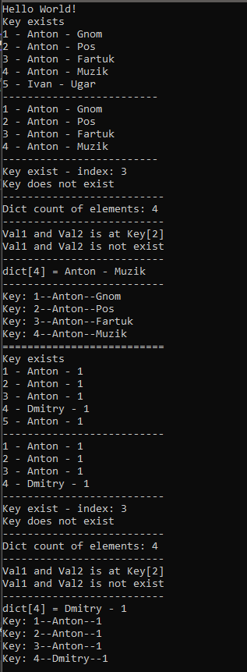

Git: https://github.com/loorkky/DotNetLab2.git

